Borehole No. F3
Location Bongkrom,Afram Plains
Latitude N 06°57.953’
Longitude W000°34.087’
Date started 24/04/2001
Date completed 24/04/2001

Summary Lithological Log
Depth(m)
From To
0 1 Soil/laterite
1 2 Soil and clay
2 4.1 Clay and ferricrete
4.1 6.1 Soft very weathered sandstone to siltstone
6.1 8.1 Fairly soft weathered mudstone
8.1 10.2 Fairly weathered siltstone with manganese
10.2 13.2 Shaley siltstone
13.2 21.3 Siltstone
21.3 24.4 Fractured siltstone
24.4 30.5 Weathered siltstone
30.5 36.6 Sandy siltstone

Detailed Photo-lithological Log

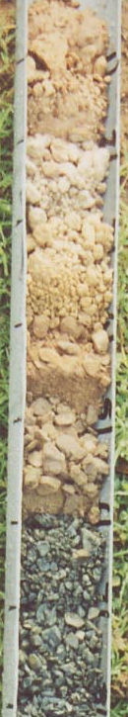
Depth (m)
0-1 2.5YR7/2 pale red silty fine sand with 7.5YR4/6 strong brown coated ferricrete of dark red haematite and black manganese nodules 10-120mm in diameter

1-2 Some 2.5YR7/2 pale red sandy soil with 2.5Y7/6 yellow clay and some 5YR5/4-6 reddish brown to yellowish red silty kaolin clay

2-3.1 2.5Y6/6 olive yellow with white specks kaolin clay with some dark red haematite ferricrete bands

3.1-4.1 2.5Y6/6 olive yellow to 6/4 light yellowish brown silty clay, some very hard red brown ferricrete

4.1-5.1 Very weathered and soft brown 7.5YR4/3 to fairly weathered black fairly hard platey shaley sandstone

5.1-6.1 Fairly weathered dark brown fine siltstone, platey fragments

6.1-7.1 Dark grey to weathered brown grey fairly soft silty mudstone

7.1-8.1 Dark grey to black platey mudstones (shales)

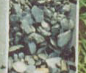

8.1-9.1 Dark grey shaley siltstone with odd brown black manganiferous weathered partings

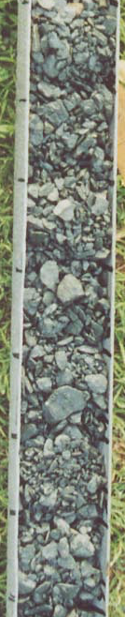
9.1-10.2 Dark grey shaley siltstone with odd brown black manganiferous weathered partings

10.2-11.2 Dark grey shaley siltstone with fine grained mica

      - Dark grey shaley siltstone with fine grained mica

12.2-13.2 Dark grey shales with interbedded siltstones

13.2-14.2 Dark grey siltstone

14.2-15.2 Dark grey siltstone with finely disseminated mica

15.2-16.3 Dark grey siltstone to fine sandstone

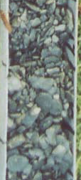

16.3-17.3 Dark grey shaley mudstone and siltstones

17.3-18.3 Dark grey shaley siltstone with some dark brown grey partings

18.3-19.3 Dark grey shaley siltstone

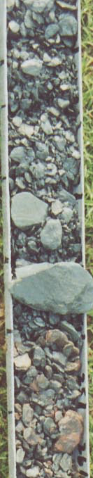
19.3-20.3 Dark grey shaley siltstone

20.3-21.3 Dark grey shaley siltstone

21.3-22.4 Dark grey siltstones and shaley mudstones with thin grey ashy bands and thin calcite bands with slickenslides?

22.4-23.4 Dark grey siltstones with competent grey bands, some mica

23.4-24.4 Very large fragments (100mm) dark grey siltstone with softer light grey platey siltstone discoloured brown. First water struck zone. Some dark grey shaley mudstone

24.4-25.4 Hard black and reddish brown siltstone with reddish brown fine to coarse-grained sandstone

25.4-26.4 Interbedded dark grey and red brown siltstone to fine-grained sandstone

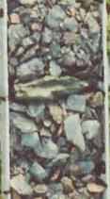

26.4-27.4 Interbedded dark grey siltstone and red brown fine-grained sandstone, with grey siltstone with brown weathered partings

27.4-28.5 Finley interbedded dark grey siltstone and red brown fine-grained sandstone with broken light grey shaley siltstone with brown partings

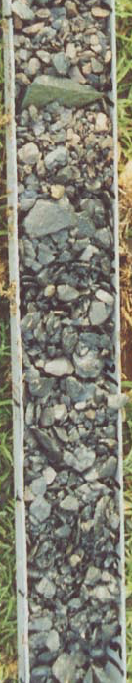
28.5-29.5 Finley interbedded dark grey siltstone and red brown fine-grained sandstone with less broken light grey shaley siltstone with brown partings

29.5-30.5 Banded dark grey and red brown siltstone to fine-grained sandstone

30.5-31.5 Dark grey platey siltstones

31.5-32.5 Hard dark grey platey siltstones with some red brown partings, almost a fine grained sandstone

32.5-33.5 Dark grey platey siltstones with some brown partings

      - Dark grey sandy siltstones

34.5-35.6 Dark grey sandy siltstones with brown partings

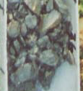

35.6-36.6 Dark grey sandy siltstones with brown partings

